**Azure Service Bus**

1. Create an azure service bus from portal
2. In Basic plan, only queues are there, in standard and premium plan both queues and topics are supported. You can directly upgrade basic to standard/premium from portal
3. So in Queue, you can send message from below program or directly from portal. From portal you can send multiple copies of a single message at once. See the screenshot. 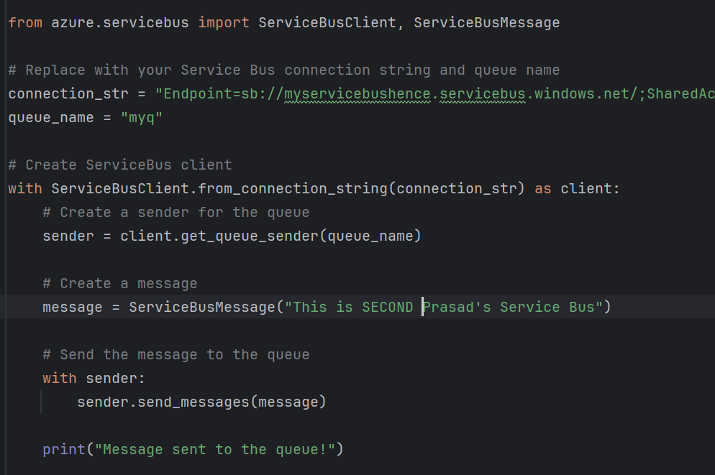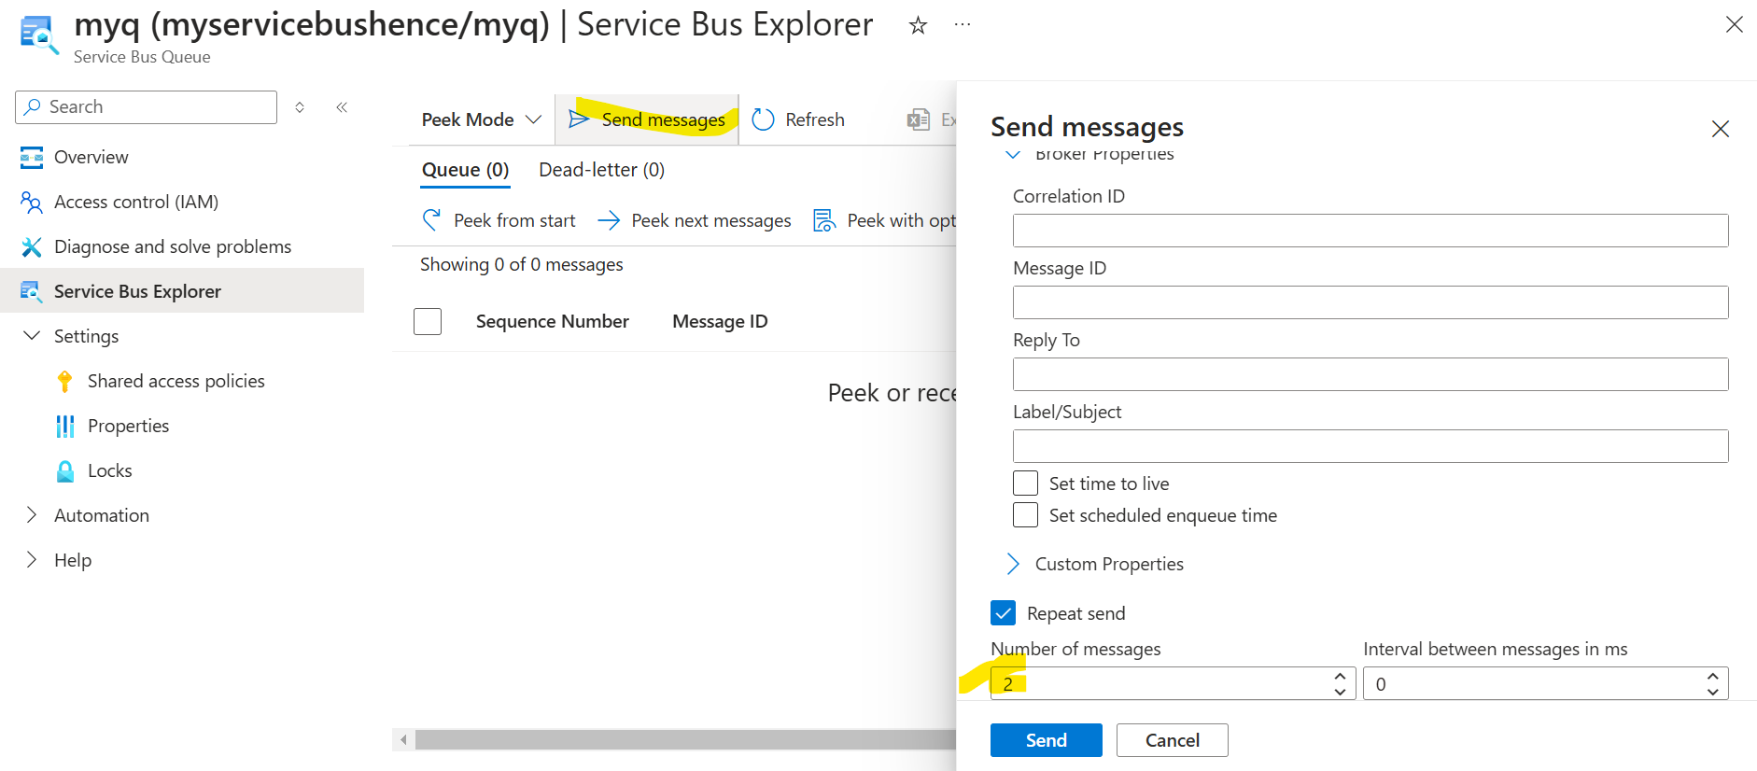
4. You can see the messages received by the queue and even download them in excel sheet. Also, alternatively you can use the below program to receive the messages from service bus as well.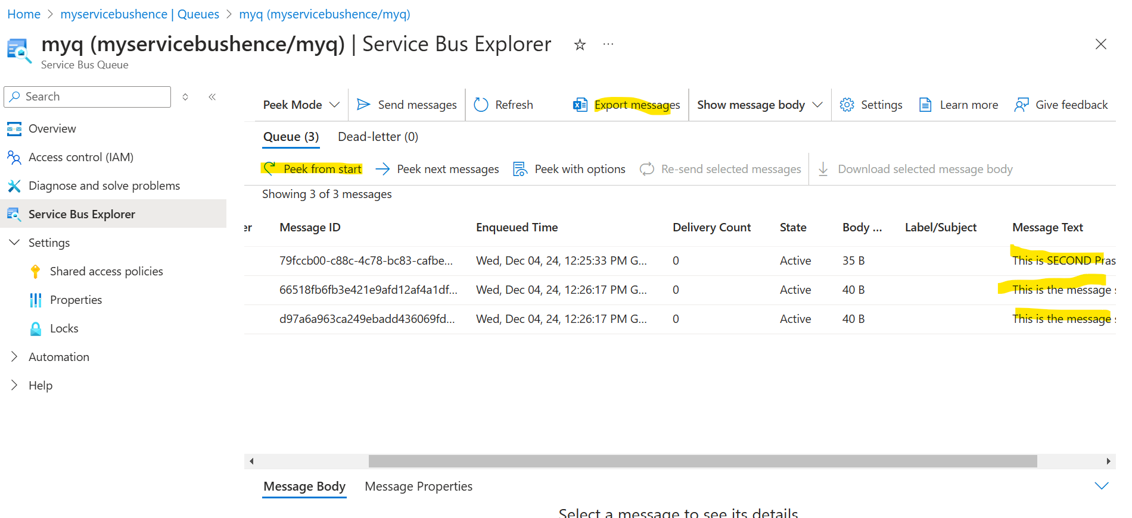 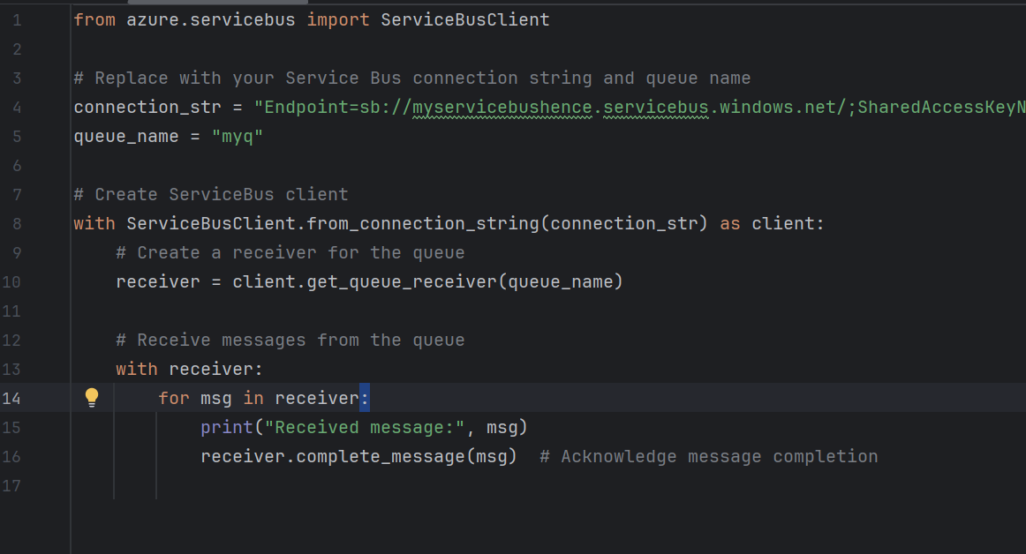
5. You can Auto-Forward the messages to other queue or topic as well. Then as soon as the message is received the queue then the messages will be transferred and you won’t be able to see them in queue. 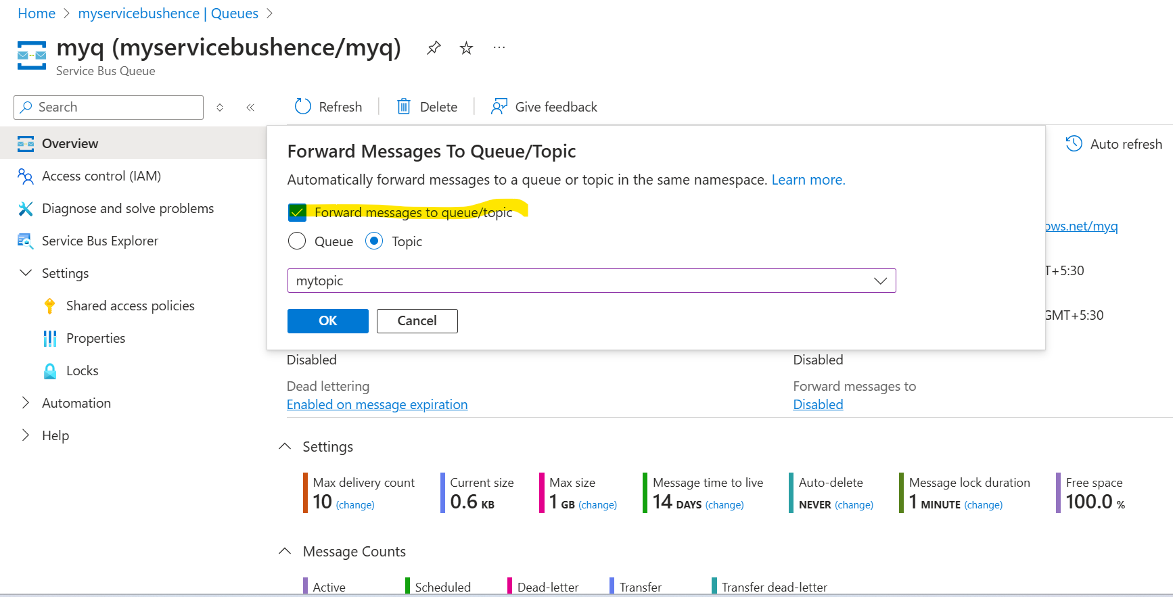
6. Remember the queue, topic and service bus itself have Shared access policy. So, if you want you can just create connection string of a queue or a topic or a whole service bus.
7. Create a topic, and inside topic you need to create subscriptions for each of the program listening to it. Each message will be replicated in each subscription. 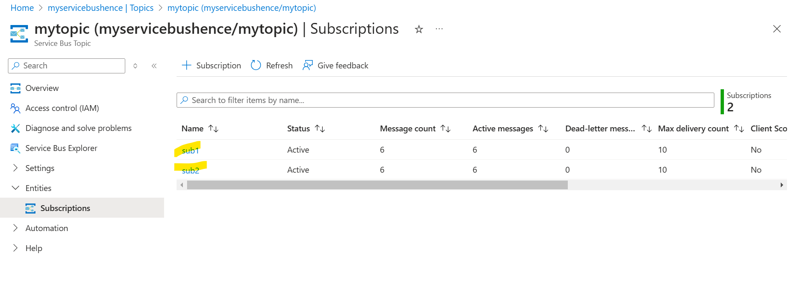
8. Below 2 programs are designed to receive the messages stacked in subscription. Remember if only one program is run, then the message for that subscription would be gone. Other will remain. 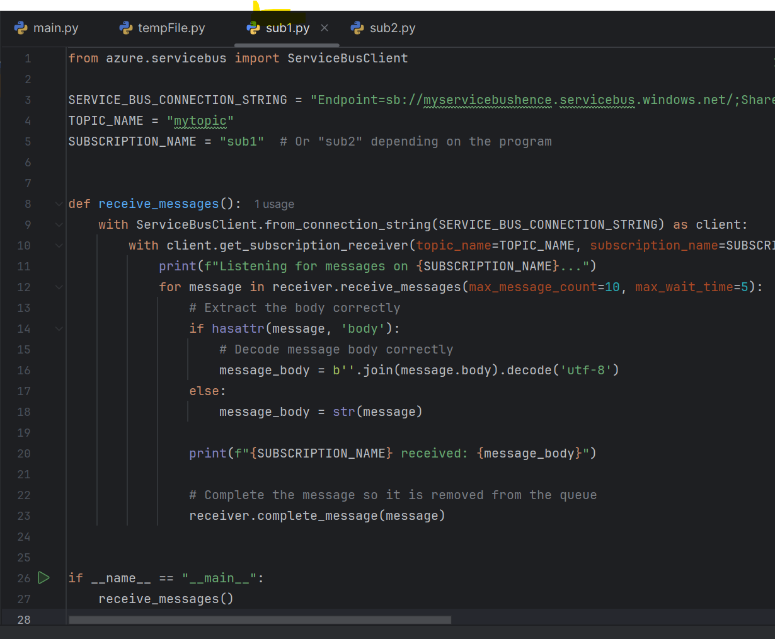 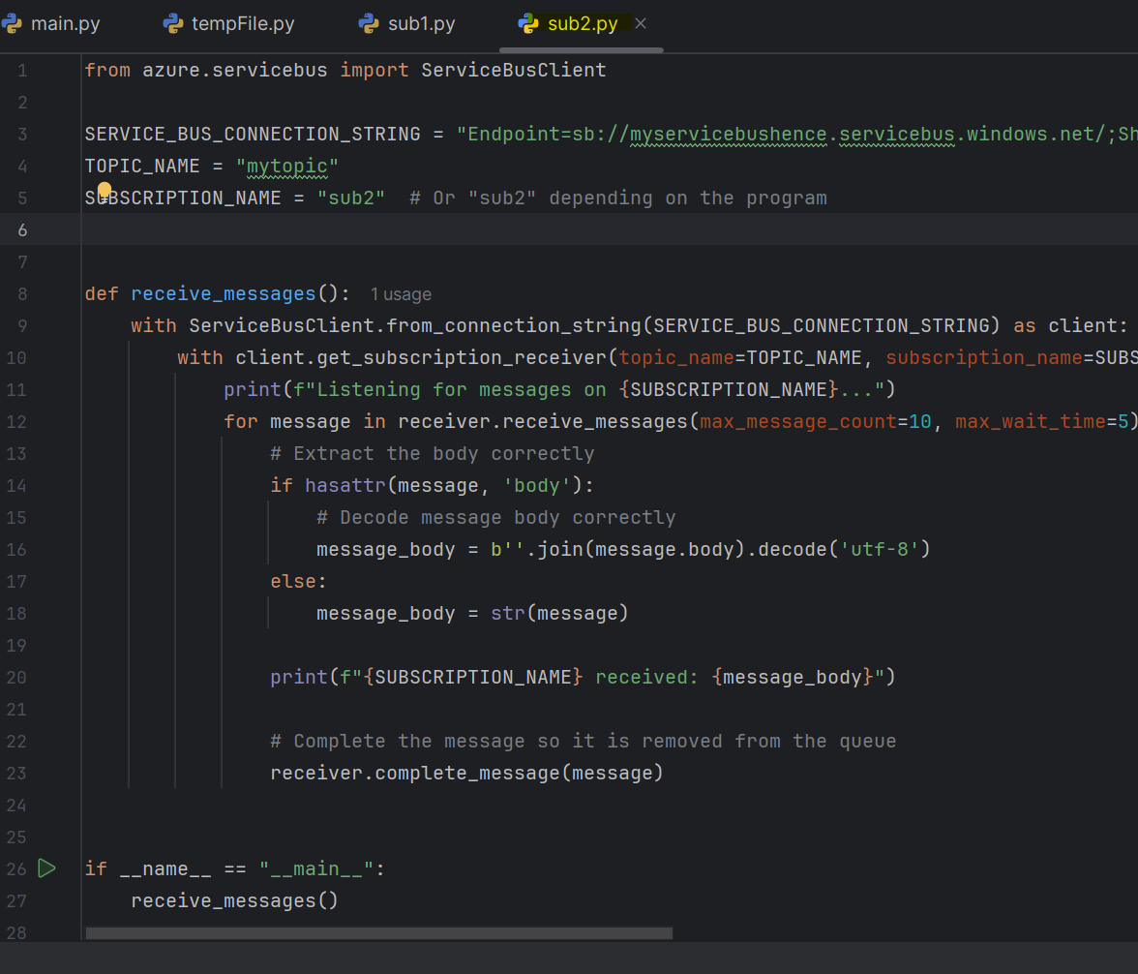 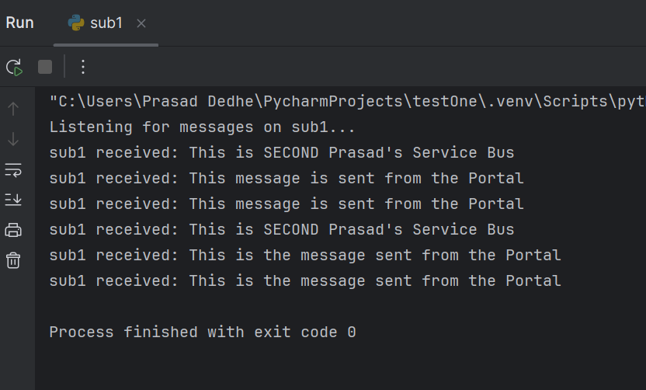 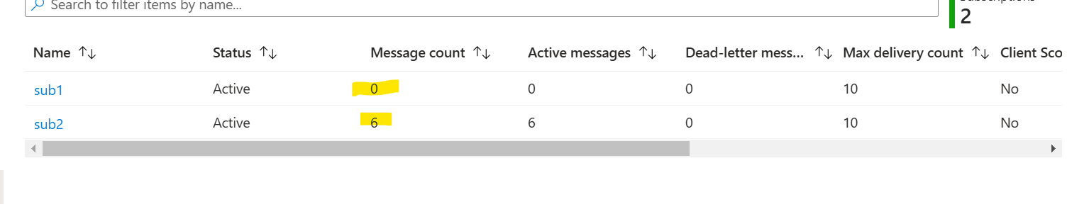
9. Remember always think like when you are booking a show on bookmyshow or any other applicatinon, there is use of case of queue. And in any application where you might want to send notifications to all users like Zomato, topics are amazing use case.